p.163, ex.2

1. a histogram – c 4. a table - a

2. a bar chart – b 5. a scatter plot - e

3. a line graph – f 6. a pipe chart – d

p.164, ex.3

1. d 4. f

2. c 5. d

3. a, b

p.164, ex.5

a) 2 d) 1

b) 4 e) 6

c) 3 f) 5

p.165, ex.8

1. Korea

2. Slovak Republic, Turkey

3. Slovak Republic

4. Korea, Austria

5. Austria

6. Korea, Turkey

7. Greece

Приклад діаграми

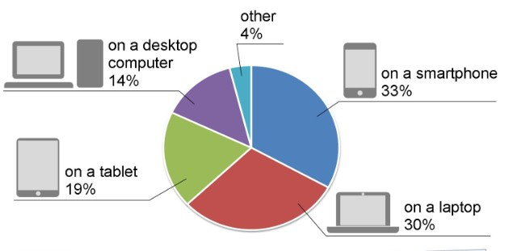

The pie chart in Figure 1 shows the results of a survey in which people aged 16 years and older were asked about their preferred Internet access devices. The question concerned access to the Internet at home and in other places. In their responses, participants mentioned four main devices: a smartphone, laptop, tablet, and desktop computer.

It is clear from the pie chart that most participants prefer to use smartphones and laptops, with a difference of only three percent. Almost a third of the participants prefer to access the Internet from a smartphone. Thirty percent love to use a laptop. The desktop computer accounts for fourteen percent of user-preferred devices. Only a small minority prefers devices other than these four main ones.

In conclusion, since mobile and portable devices are the most popular choice, it is obvious that many participants have access to the Internet outside their homes. The desktop computer is the least popular of the four main devices. In the future, we can probably expect more and more people to access the Internet with smartphones as their preferred choice.

p.149, ex.12

also - 6

however - 3

as a result

secondly - 4

initially

thirdly - 5

in contrast

finally - 1

overall - 2

p.149, ex.12

цифри — співставлення з вправою 14.

enhanced - 4 improved, made better

escalated - 6 became higher

expected - 1 assumed

objective - 7 aim

examine - 10 study

impacts - 2 influences

administered to - 8 given to

is likely - 5 will probably have

to have - 4 improved, made better

aspects - 9 parts

interaction - 3 communication

Письмове завдання

Most teachers and parents suggest that introducing games into the learning process will not lead to better teaching and learning. This article discusses these assumptions in a junior school located in California. Our qualitative methodology included, firstly, interviews with teachers, schoolchildren, secondly, observations in the classroom about the learning process, and finally, surveys of both teachers and schoolchildren of this educational institution. We found that when teachers used game components to conduct the learning process in the classroom, the activity of schoolchildren increased. As a result, they became more interested in studying. We offer explanations of this problem for the dominant assumptions that determine the current policy that shapes the learning process in elementary schools .. In general, the traditions in this school will affect the slow revolution in the teaching practice of elementary schools.

p.149, ex.12

1)

- What a wonderful garden garden you have!

- Do you really think so?

- Yes, I do. This flowers are so odorous.

- How nice of you to say that.

2)

- Y'all have done a really good job. Congratulations!

- I'm glad you liked it.

- Your presentation were fantastic.

- It was nothing special, really.

3)

- I heard you have just got your PhD degree. Good job.

- Thank you very much. How nice of you to say that.

- It was hard to had it ?

- It wasn't difficult at all.

4)

- Dear professor from Denmark. Welcome to our university. Look at our facilities.

- Ok. Let do this.

- We have well-equipped computer centre and a new library.

- What a wonderfull equipped!

- Thank. I'm glad you liked it.

5)

- Hello, Sasha. Heard you bought new smartphone.

- Yes, I bought.

- Can you show it?

- Yes. You can see.

- I like the design of this smarthone.

- What a wonderfull design.

- Do you really think so? Thanks.

- Can you tell me about functionality of this smarthone?

- Yes. This smartphone have many functions, like camera, internet, compass, calculator, gallery, music and other.

- So many fucntions. Amazing.

6)

- Hello, Vlad. How are you.

- Hi, Maxim. Good, and you?

- I'm fine. I'm have a good news.

- What's news ?

- My son has just entered Cambridge.

- Good job. Congratulations!

- Thank you very much.

7)

- Hello, Sasha. I seen your presentation completely.

- Hi. And what you think bout it.

- Your slides presentation were fantastic!

- Do you really think so? Thanks.

- What about your prospect of further research?

- I planning to continue this research on next year.